🚀 Universal Stationary E-Commerce Platform - Developer Guide

Table of Contents
- Project Overview
- Architecture & Tech Stack
- File Structure & Navigation
- Core Components Deep Dive
- Data Layer & State Management
- UI/UX System
- Security & Performance
- Deployment & Maintenance

Project Overview
Universal Stationary is a modern, client-side e-commerce platform for premium stationery brands (STAPLES, Parker, Faber-Castell) targeting the Pakistani market. The platform features a playful “kids-friendly” aesthetic while maintaining professional e-commerce functionality.

Key Features
- Product Catalog: 27+ products across 3 major brands
- Battle Arena: Product comparison tool (2-item compare)
- Shopping Cart: Persistent localStorage-based cart system
- Checkout Flow: Multi-step checkout with confetti celebration
- Dark Mode: Theme switching capability
- 3D Backgrounds: Three.js animated backgrounds
- Responsive Design: Mobile-first Bootstrap 5 architecture

Architecture & Tech Stack

Frontend Stack
Layer | Technology | Purpose
Structure | HTML5 | Semantic markup
Styling | Bootstrap 5.3 + Custom CSS | Responsive grid + themed components
Typography | Fredoka + Quicksand (Google Fonts) | Brand personality
Animations | Three.js + Animate.css + Typed.js | 3D backgrounds, entrance animations, text effects
Interactions | Vanilla JavaScript (ES6+) | All business logic
Storage | localStorage | Cart & compare list persistence

No Backend Architecture
This is a static site (JAMstack-ready) with:
- No server-side processing
- Client-side data management via localStorage
- Form submissions handled via mailto: links or client-side simulation

File Structure & Navigation
/mnt/kimi/upload/
├── index.html # Landing page (Hero + Features)
├── shop.html # Product catalog (Core commerce)
├── about.html # Brand story + Team
├── contact.html # Contact form + 3D alerts
├── compare.html # Product comparison (Battle Arena)
├── checkout.html # Checkout flow + Success overlay
└── checkout - Copy.html # Backup/variant of checkout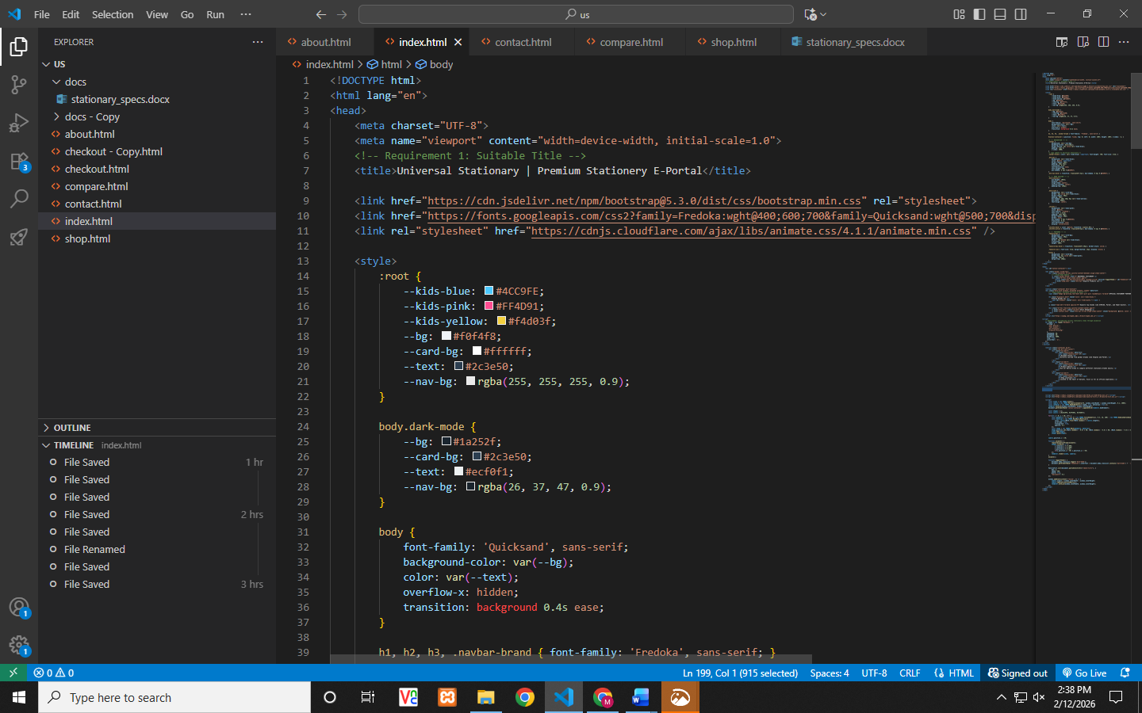Navigation Flow
[Home] ←→ [Shop] ←→ [Compare]
↓ ↓ ↓
[About] [Cart] [Checkout]
↓ ↓
[Contact] [Checkout]

Core Components Deep Dive

1. Product Catalog System (shop.html)

Data Structure
// Standardized product schema
{
id: "FC001", // Brand prefix + number
name: "Product Name", // Descriptive title
brand: "Faber-Castell", // Categorization
price: 1699, // PKR currency
desc: "Detailed...", // SEO-friendly description
img: "https://..." // External CDN image
}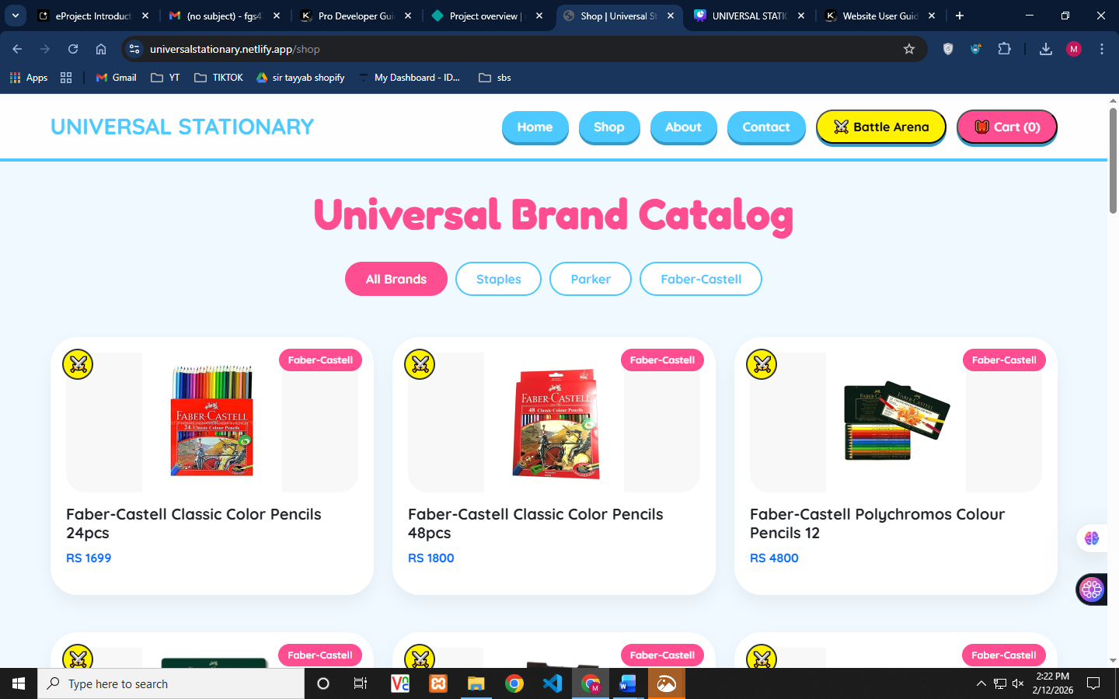

Product Rendering Engine
// Dynamic grid generation with VanillaTilt 3D effects
function renderProducts() {
const filtered = currentBrand === 'all'
? allProducts
: allProducts.filter(p => p.brand === currentBrand);
// Generates Bootstrap cards with tilt effect
grid.innerHTML = filtered.map(item => `
<div class="col-md-4 mb-4">
<div class="product-card" data-tilt>
<!-- Product markup -->
</div>
</div>
`).join('');
VanillaTilt.init(document.querySelectorAll(".product-card"));
}

Key Features
- Category Filtering: Pill-based brand filter (All, Staples, Parker, Faber-Castell)
- Battle Mode: ⚔️ button adds to compare list (max 2 items)
- Quick View: Modal popup with product details
- Add to Cart: Instant cart update with badge counter

2. Shopping Cart Architecture

State Management
// Singleton cart state
let cart = JSON.parse(localStorage.getItem('universalCart')) || [];
// Cart operations
function addToCart(item) {
cart.push({name, price});
localStorage.setItem('universalCart', JSON.stringify(cart));
updateCartUI();
}
function updateCartUI() {
// Updates sidebar + header badge
document.getElementById('cartCount').innerText = cart.length;
renderCartItems();
calculateTotal();
}

Cart Sidebar (Slide-out Panel)
- Position: Fixed right panel (right: -420px → right: 0)
- Animation: CSS transition 0.5s ease
- Contents: Item list, quantity, total, checkout CTA
- Persistence: Survives page reloads via localStorage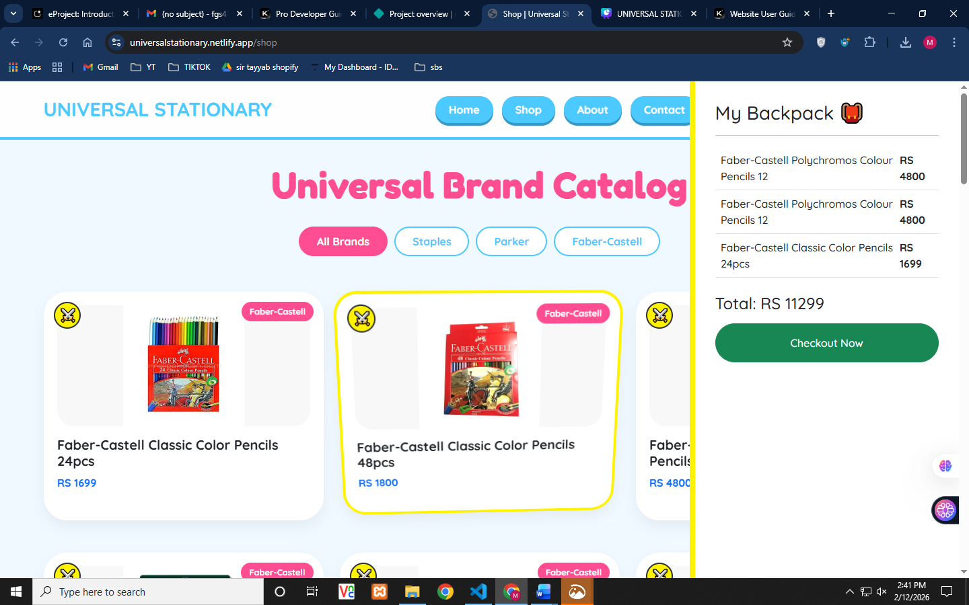

3. Battle Arena Comparison (compare.html)

Compare List Logic
// Max 2 items, FIFO replacement
function addToCompare(e, item) {
e.stopPropagation(); // Prevent modal opening
let list = JSON.parse(localStorage.getItem('compareList')) || [];
if(list.length >= 2) list.shift(); // Remove oldest
list.push(item);
localStorage.setItem('compareList', JSON.stringify(list));
}

UI Pattern
- VS Badge between products
- Side-by-side spec comparison
- “Choose Winner” CTA (visual only) 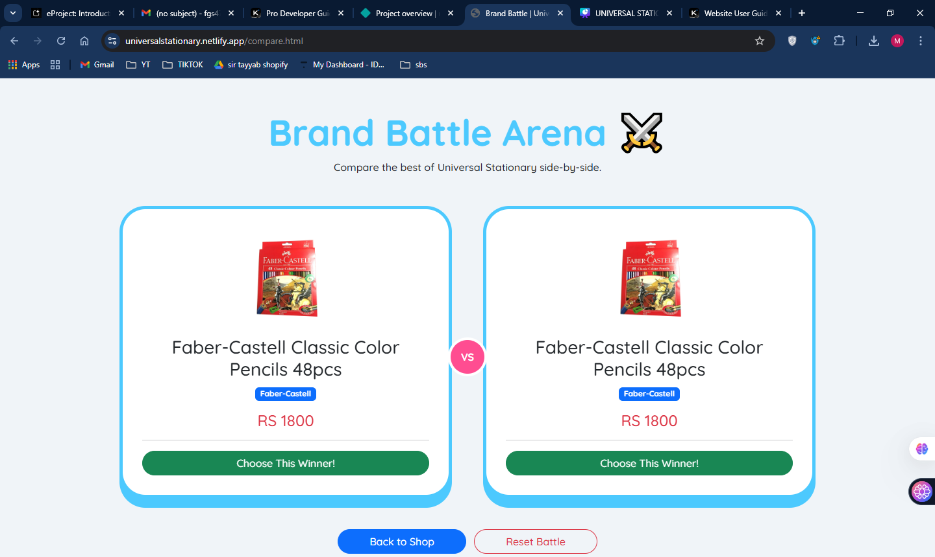

4. Checkout System (checkout.html)

Multi-step Flow
- Delivery Form: Name, Address, Phone, Payment Method
- Order Summary: Real-time cart display
- Success Overlay: Confetti celebration + Order ID generation

Security Considerations
// Order ID generation (client-side only)
const orderID = "UNIV-" + Math.floor(100000 + Math.random() * 900000);
// Form validation: HTML5 required attributes
// Payment: Select dropdown (no actual processing)

Success Animation
// Canvas Confetti integration
confetti({
particleCount: 150,
spread: 70,
origin: { y: 0.6 },
colors: ['#4CC9FE', '#FF4D91', '#FFF200'] // Brand colors
});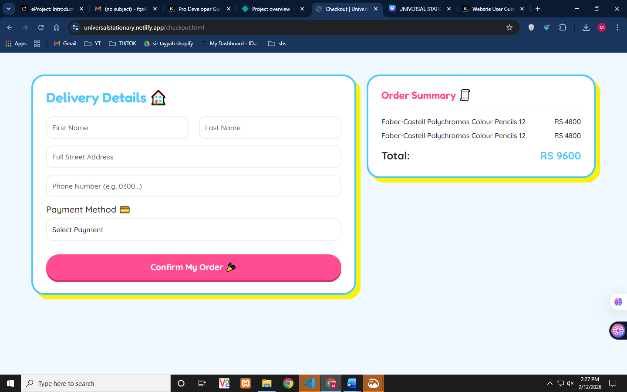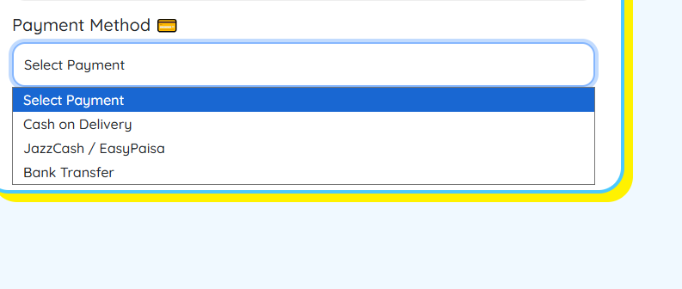

5. 3D Background System (Three.js)

Implementation Pattern (used in index.html, about.html, contact.html)
// Scene setup
const scene = new THREE.Scene();
const camera = new THREE.PerspectiveCamera(75, window.innerWidth/window.innerHeight, 0.1, 1000);
const renderer = new THREE.WebGLRenderer({ alpha: true, antialias: true });
// Animated shapes (Torus, Icosahedron, Dodecahedron)
const shapes = [];
const colors = [0x4CC9FE, 0xFF4D91, 0xf4d03f]; // Brand palette
// Animation loop
function animate() {
requestAnimationFrame(animate);
shapes.forEach(s => {
s.rotation.x += 0.005;
s.rotation.y += 0.005;
s.position.y += 0.01; // Floating effect
if(s.position.y > 30) s.position.y = -30; // Reset
});
renderer.render(scene, camera);
}

Performance Optimization
- alpha: true for transparent background
- wireframe: true with low opacity (0.1-0.2)
- Limited object count (15-20 shapes max)
- window.addEventListener('resize') for responsive canvas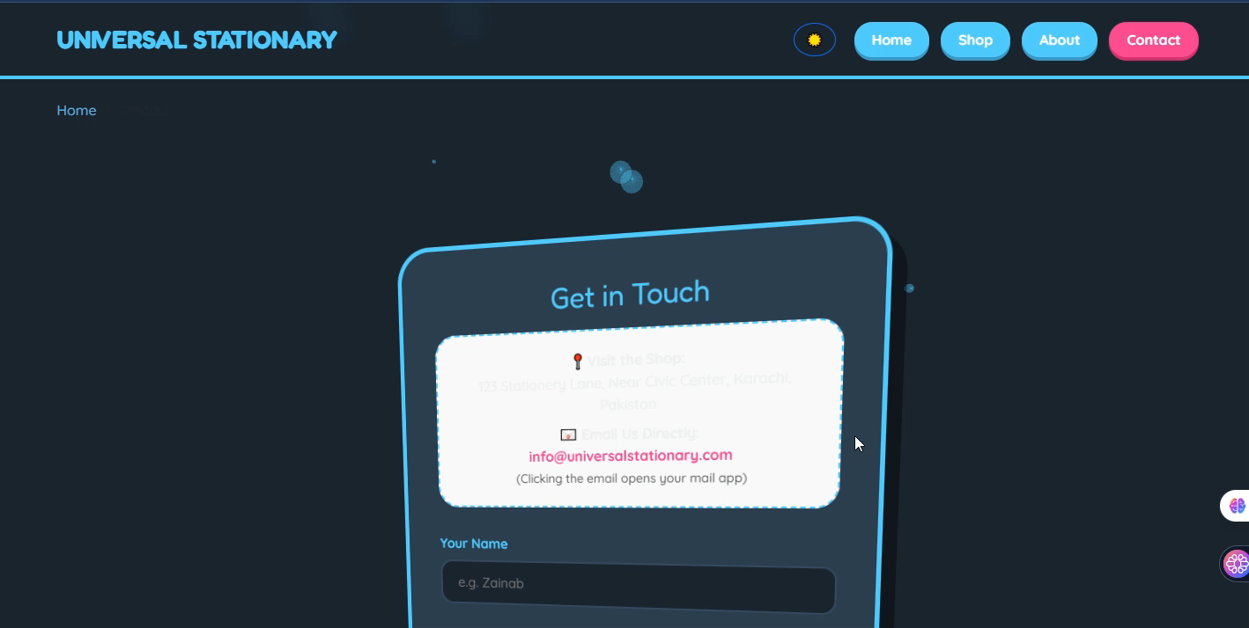

Data Layer & State Management

localStorage Schema
Key | Structure | Usage
universalCart | [{name, price}] | Shopping cart items
compareList | [{name, price, img, brand}] | Battle arena items

Data Flow Diagram
User Action → JavaScript Handler → localStorage Update → UI Re-render
↑ ↓
Event Listener ←──────────────────────────────── DOM Update

No API Integration
- Static Data: Hardcoded in shop.html (27 products)
- No Database: All data client-side
- No Authentication: Anonymous shopping experience

UI/UX System

Design System (CSS Variables)
:root {
/* Brand Colors */
--kids-blue: #4CC9FE; /* Primary actions */
--kids-pink: #FF4D91; /* CTAs, accents */
--kids-yellow: #FFF200; /* Highlights, shadows */
/* Functional */
--bg: #f0f4f8; /* Light mode bg */
--card-bg: #ffffff; /* Card surfaces */
--text: #2c3e50; /* Primary text */
}
body.dark-mode {
--bg: #1a252f;
--card-bg: #2c3e50;
--text: #ecf0f1;
}

Component Patterns

3D Card Effect
.product-card {
border-radius: 35px;
box-shadow: 0 10px 20px rgba(0,0,0,0.05);
transition: 0.4s;
}
.product-card:hover {
transform: translateY(-10px);
border: 4px solid var(--kids-yellow);
box-shadow: 15px 15px 0px var(--glow);
}

Neubrutalism Button Style
.btn-nav {
background: var(--kids-blue);
border-radius: 50px;
box-shadow: 0 4px 0 #3699C7; /* 3D press effect */
transition: 0.3s;
}
.btn-nav:hover {
transform: translateY(-3px);
box-shadow: 0 6px 0 #3699C7;
}
.btn-nav:active {
transform: translateY(4px);
box-shadow: none;
}

Responsive Breakpoints
- Mobile: < 576px (single column)
- Tablet: 576px - 992px (2 columns)
- Desktop: > 992px (3-4 columns) 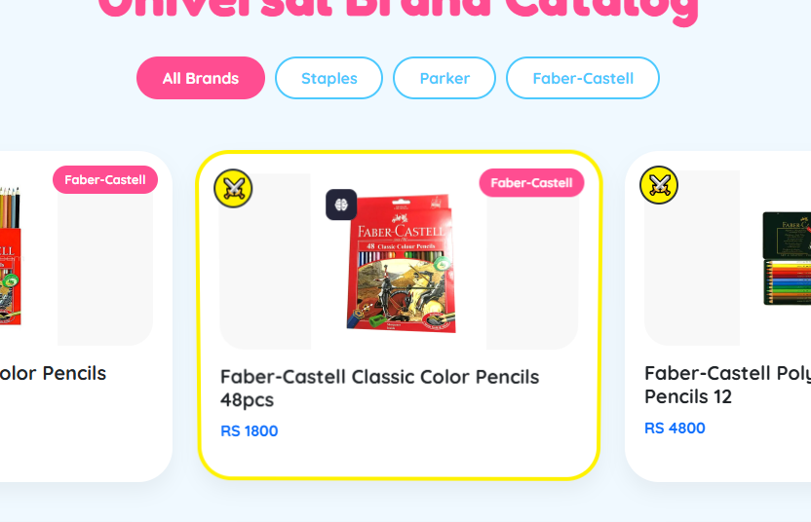

Security & Performance

Security Assessment
Aspect | Status | Notes
XSS Protection | ⚠️ Basic | No input sanitization on contact form
CSRF Protection | ✅ N/A | No server-side state
Data Validation | ⚠️ Client-side only | HTML5 required attributes
HTTPS | ✅ Recommended | External images use HTTPS
Payment Security | ⚠️ Simulation | No actual payment processing

Performance Optimizations

Image Strategy
<!-- External CDN images (lazy loading implied) -->
<img src="https://img.drz.lazcdn.com/...webp"
style="object-fit: contain; max-height: 100%;">

Script Loading
- CDN Resources: Bootstrap, Three.js, Fonts (cached)
- Defer Strategy: No async/defer currently (improvement opportunity)
- Bundle Size: ~500KB total external resources

Critical Improvements Needed
- Add loading="lazy" to product images
- Implement service worker for offline capability
- Minify custom CSS/JS (currently unminified)
- Add resource hints: preconnect for CDNs

Deployment & Maintenance

Hosting Requirements
- Static Hosting: GitHub Pages, Netlify, Vercel, or traditional web server
- No Server Requirements: Apache/Nginx serving static files only
- Domain: Custom domain recommended for production

Deployment Checklist
# Pre-deployment verification
□ All href links use relative paths (./shop.html)
□ External images load via HTTPS
□ localStorage keys are namespaced (universalCart, compareList)
□ 3D backgrounds degrade gracefully (WebGL disabled browsers)
□ Contact form mailto: link functional
□ Checkout success flow tested end-to-end

Maintenance Tasks

Content Updates
To add new products, edit shop.html:
const newProduct = {
id: "ST011",
name: "New Product Name",
brand: "STAPLES",
price: 999,
desc: "Description...",
img: "https://image-url.webp"
};
// Add to staplesData array

Seasonal Updates
- Footer Year: Update &copy; 2026 annually
- Product Images: Monitor external CDN links for breakage
- Prices: Update PKR values as needed

Debugging Tools

Browser Console Commands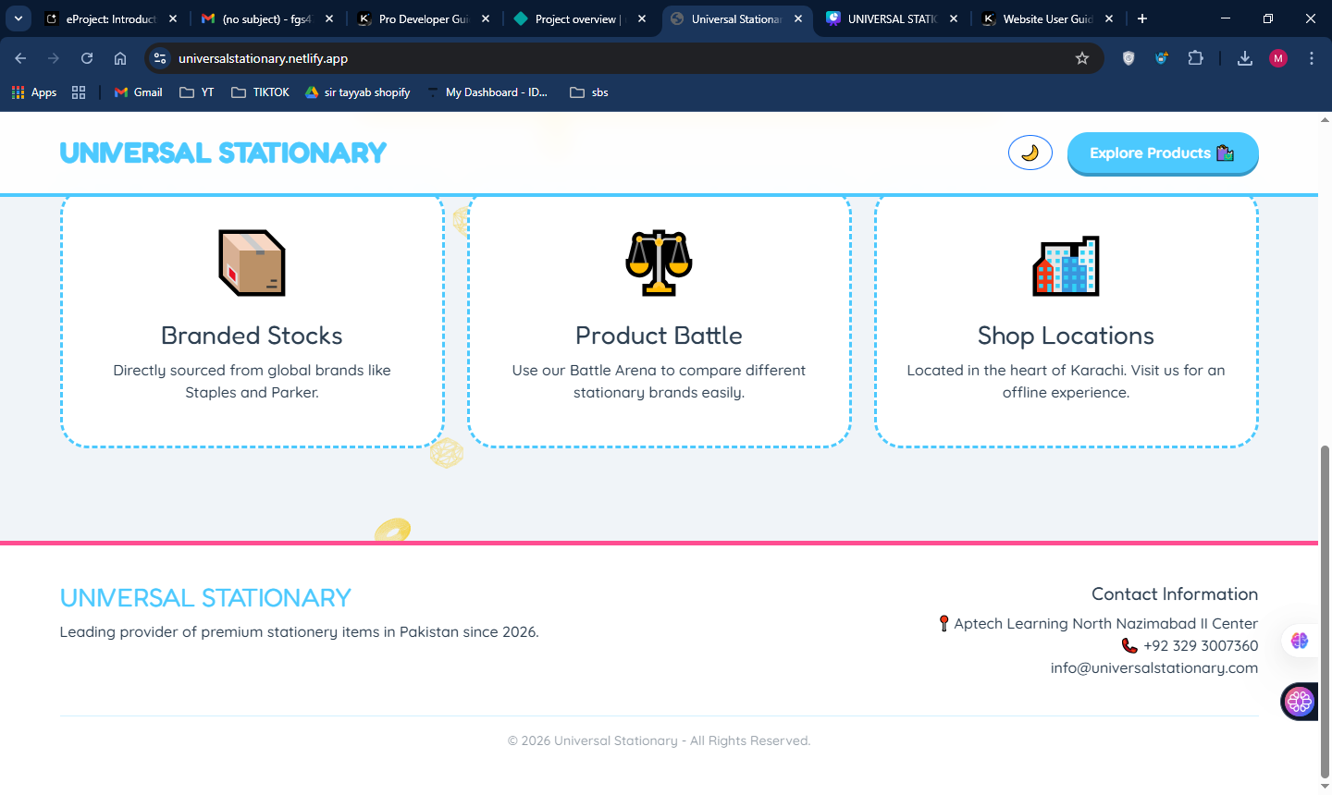
// Clear cart
localStorage.removeItem('universalCart');
// View compare list
JSON.parse(localStorage.getItem('compareList'));
// Test dark mode
document.body.classList.toggle('dark-mode');

API Reference (Internal)

Global Functions
Function | Location | Purpose
renderProducts() | shop.html | Renders product grid
addToCompare(e, ...) | shop.html | Adds to comparison
toggleCart() | shop.html | Toggles cart sidebar
placeOrder() | checkout.html | Processes checkout
toggleTheme() | All pages | Switches dark/light mode
showNestAlert() | contact.html | 3D custom alert modal

localStorage Events
Listen for storage changes across tabs:
window.addEventListener('storage', (e) => {
if(e.key === 'universalCart') {
updateCartUI(); // Sync cart across tabs
}
});

Future Enhancement Roadmap

Phase 1: Quick Wins
- ☐ Add lazy loading to images
- ☐ Implement search functionality
- ☐ Add product quantity controls in cart
- ☐ Email validation regex

Phase 2: Feature Expansion
- ☐ User authentication system (Firebase/Auth0)
- ☐ Real payment gateway integration (Stripe/PayPal)
- ☐ Product reviews/ratings
- ☐ Wishlist functionality

Phase 3: Scale
- ☐ Headless CMS integration (Strapi/Contentful)
- ☐ Progressive Web App (PWA) features
- ☐ Server-side rendering for SEO
- ☐ Analytics integration (Google Analytics 4)

Conclusion
The Universal Stationary platform demonstrates a modern static e-commerce architecture leveraging client-side technologies for rapid deployment and zero server costs. The playful UI/UX design targeting the Pakistani market, combined with robust localStorage-based state management, creates an engaging shopping experience without backend complexity.
Key Strengths: Visual design, 3D interactions, responsive layout, zero hosting costs
Improvement Areas: Input sanitization, lazy loading, PWA capabilities, real payment processing

